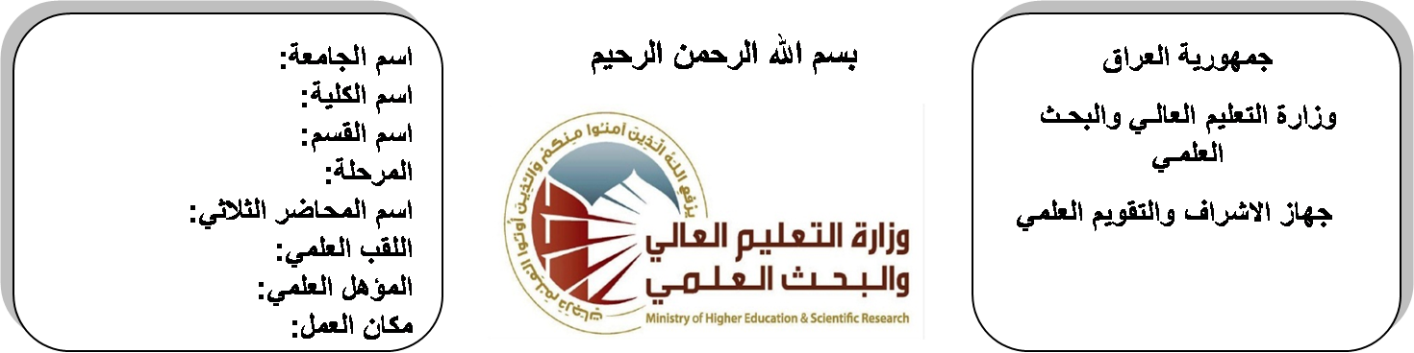

**University: Diyala University**

**College: College of Engineering**

**Department: Electronic Engineering**

**Stage: Second**

**Lecturer name:Wisam Najm AL-Din Abed**

**Qualification: M.Sc**

**Place of work: Electronic Dept.**

**Republic of Iraq**

**Ministry of Higher Education**

**& Scientific Research**

**(( Annual teaching plan form))**

|  |  |  |  |  |
| --- | --- | --- | --- | --- |
| **Lecturer Name** | **Wisam Najm AL-Din Abed** | | | |
| **Email** | **Wisam_alobaidee@yahoo.com** | | | |
| **Subject** | **Electrical Circuits** | | | |
| **Aims** | **The aim of this subject is to make the students ready to undestand and comprehend the scientific theories and their applications related to their field of the study.** | | | |
| **Textbooks** | ELETRIC CIRCUITS BY J.A.EDMINSTER | | | |
| **Additional Textbooks** | ELETRIC CIRCUITS BY MAHMOOD & J.A.EDMINSTER | | | |
| **Assessments** | **First Semester** | **Second Semester** | **Laboratory** | **Final Exam** |
| 20% | 20% |  | 60% |
| **Notes** |  | | | |

**Schedule Weekly Lessons - First Semester**

|  |  |  |  |  |
| --- | --- | --- | --- | --- |
| **Week** | **Date** | **Lectures** | **Lab. Experments** | **Notes** |
| 1 | **29/9** | The Transient Circuits |  |  |
| 2 | **5/10** | The Transient Circuits |  |  |
| 3 | **12/10** | The Transient Circuits |  |  |
| 4 | **19/10** | The Transient Circuits |  |  |
| 5 | **26/10** | Single-phase three wire system |  |  |
| 6 | **2/11** | circle diagram |  |  |
| 7 | **9/11** | 3- phase balance and unbalance system star and delta connection |  |  |
| 8 | **16/11** | power in 3-bhase circuits |  |  |
| 9 | **23/11** | **Coupling** |  |  |
| 10 | **30/11** | Magnetic coupling |  |  |
| 11 | **7/12** | coefficient of coupling |  |  |
| 12 | **14/12** | equivalent circuits linear and ideal transformers |  |  |
| 13 | **21/12** | Two –Port Network |  |  |
| 14 | **28/12** | One–port network |  |  |
| 15 | **4/1** | y-z-h-g and ABCD parameters |  |  |
| 16 | **11/1** | image and iterative operation |  |  |
| Half Year holiday | 15/1 to  1/2 |  |  |  |

**Lecturer Signature Head of Dept. Signature Dean Signature**

**Schedule Weekly Lessons - Second Semester**

|  |  |  |  |  |
| --- | --- | --- | --- | --- |
| **Week** | **Date** | **Lectures** | **Lab. Experments** | **Notes** |
| 1 | **15/2** | attenuation and phase function |  |  |
| 2 | **22/2** | attenuation and phase function |  |  |
| 3 | **1/3** | **Two –Port Network** |  |  |
| 4 | **8/3** | **Two –Port Network** |  |  |
| 5 | **15/3** | **Two –Port Network** |  |  |
| 6 | **22/3** | attenuation and phase function |  |  |
| 7 | **29/3** | interstice loss of network |  |  |
| 8 | **5/4** | interstice loss of network |  |  |
| 9 | **12/4** | Constant k- filters |  |  |
| 10 | **19/4** | low pass and high pass |  |  |
| 11 | **26/4** | low pass and high pass |  |  |
| 12 | **3/5** | modern filter design |  |  |
| 13 | **10/5** | butterworth and chebyshev filters |  |  |
| 14 | **17/5** | butterworth and chebyshev filters |  |  |
| 15 | **24/5** | network transformation, and all pass filter |  |  |
| 16 | **1/6** | active filter |  |  |

**Lecturer Signature Head of Dept. Signature Dean Signature**